PIZZA SALES SQL QUERIES
A.KPI
1. Total Revenue
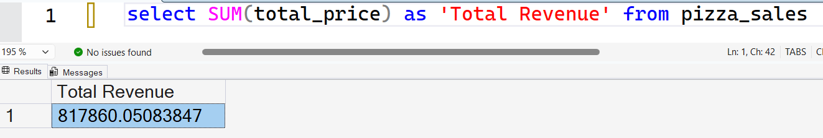
2. AOV
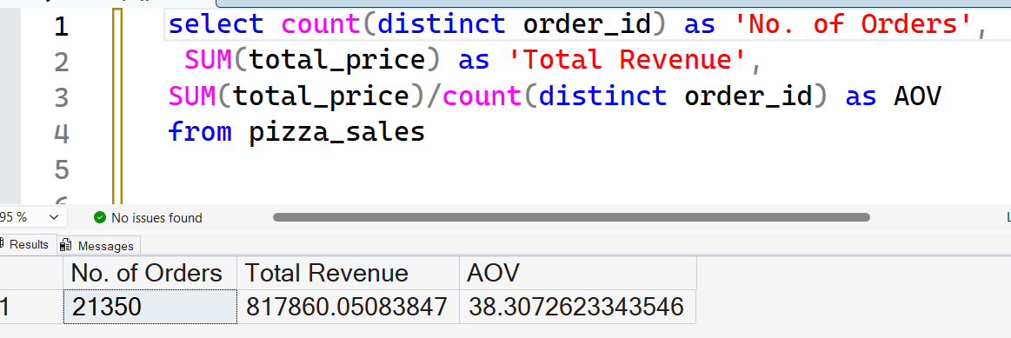
3. TOTAL PIZZAS SOLD
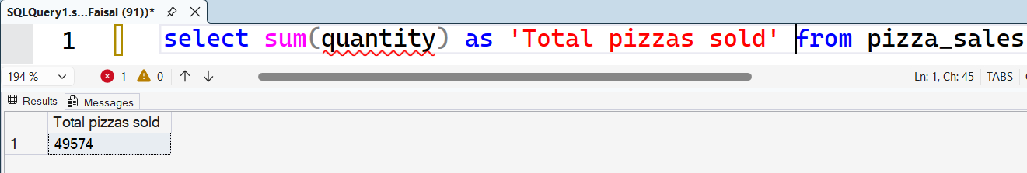

4. TOTAL ORDERS
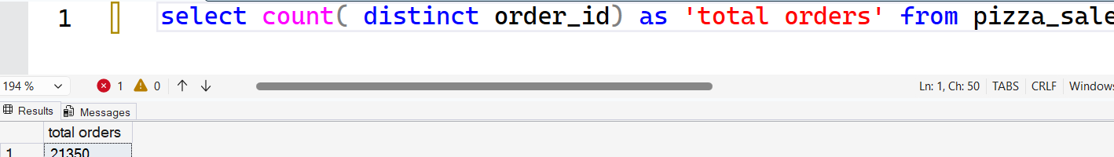
5. AVERAGE PIZZAS PER ORDER
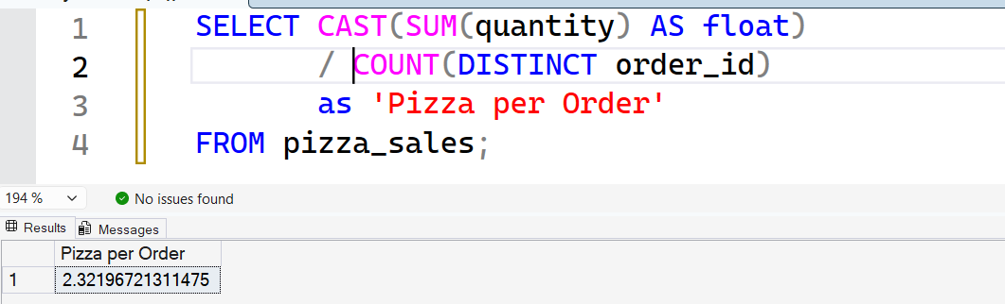
B. CHARTS REQUIREMENT
1] Daily Trend

2]Monthly trend
3]Percentage of Sales by Pizza Size
4] Percentage of Sales by Pizza Category
5] Total Pizzas Sold by Pizza category
6] Top 5 best by
6.1-Revenue
6.2-Total Quantity
6.3-Total Orders
7] Worst 5 best by
7.1-Revenue

7.2-Total Quantity

7.3-Total Orders

